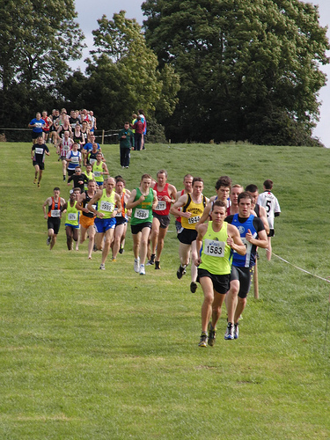

**DATE:** Sunday, 25th September 2022

**TIME:** 11.00 am (Juvenile races)

1.00pm (Jun, Sen, Mas, )

**LOCATION:** Greenanstown, Stamullen, Co. Meath

All races chip timed

**A great day out for joggers and runners of all ages. You don’t even have to be a member of a club!**

**This year marks the 50th Anniversary of the founding of the club in 1972.**

**Prizes:**

***Juv. Races (under 9 – under 17):*** 1st 6 finishers and 1st 3 teams (3 per team).

***Jun., Sen. & Masters race: CASH PRIZES***

1st 6 finishers overall, 1st 3 Juniors & 1st 3 Masters o/40, o/50, o/55.

PLUS: 1st two combined Jun./Sen. teams and 1st two combined Master team (3 per team).

Race length: 3km (Women), 6km (Men)

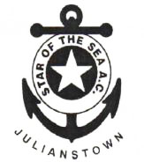

For further information contact:

Brendan Meade

087 2533113

bmeade@iol.ie

**Note**: **All entries for both juvenile and senior races to be done online. No entries on the day.**

**Numbers will be given out in car-park field. Everyone with a race number will have free admission. All adult spectators will pay €5 at the gate to cross country field**

**Star of the Sea A.C.**

32nd Annual

Cross Country Meeting

and Fun Run