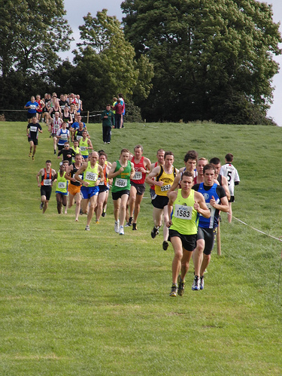

**DATE:** Sunday, 25th September 2016

**TIME:** 11.00 am (Juvenile races)

1.00 pm (Jun, Sen, Mas, & Fit4Life)

**ADMISSION:** €5 (adults) & €3 (under 18s)

**LOCATION:** Greenanstown, Stamullen, Co. Meath

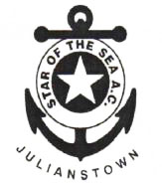

**A great day out for joggers and runners of all ages. You don’t even have to be a member of a club!**

**Prizes:**

***Juv. Races (under 9 – under 17):*** 1st 6 finishers and 1st 3 teams (3 per team).

***Jun., Sen. & Masters race: CASH PRIZES***

1st 6 finishers overall, 1st 3 Juniors & 1st 3 Masters o/40, o/50, o/55.

PLUS: 1st two combined Jun./Sen. teams and 1st combined Master team (3 per team).

**Plus team categories for the 1st 2 bona fide Fit4Life Teams male & female.**

Race length: 3km (Women), 6km (Men)

For further information contact:

Brendan Meade

087 2533113

bmeade@iol.ie

**RACE FEE:** €15 which includes admission fee of €5 for all Jun, Sen, Mas & Fit4Life athletes - paid at registration on the day. No registration after 12.30 pm. Registration desk will be at entrance to running field.

Pre-enter Junior, Senior, Master and Fit4Life categories by copying the link below and then collect your number on payment that day:

https://docs.google.com/forms/d/e/1FAIpQLSfRY2fJ1tZyFu3Np_N20JDnQ-nlr9TSaWu1u8S8Rs8C5cpMjQ/viewform?c=0&w=1

**Star of the Sea A.C.**

28th Annual

Cross Country Meeting

and Fun Run