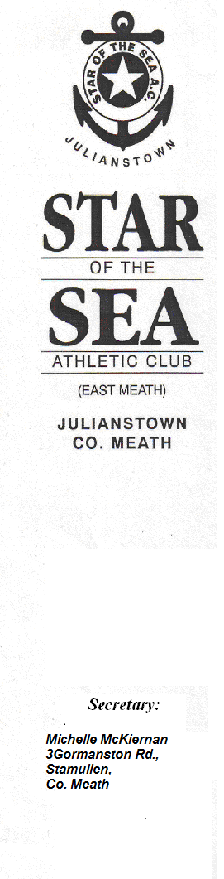

Dear Athletic Club,

We are holding our 28th annual Cross Country meeting on
Sunday 25th September 2016 at Greenanstown,
Stamullen, Co. Meath. Note: Venue will be signposted
from Cooperhill Cross on the Duleek to Julianstown road and from Stamullen village.

I enclose a summary of the programme for the day’s events. An added attraction will be the Star of the Sea Shield for the best juvenile club – the current holders are Mullingar Harriers AC.

All team races – Juv., Sen., Masters & Fit4Life are 3 per team.

Juvenile races: prizes for the 1st 6 finishers and the 1st 3
teams.

Junior, Senior & Master Races: Cash prizes for the 1st 6 finishers overall, 1st 3 Juniors and 1st 3 in Masters O/40, O/50 & O/55. Also cash prizes for 1st two Jun/Sen team of 3 and 1st Master team of 3.
We have retained the category for bona fide Fit4Life runners with prizes for the 1st 2 Fit4Life teams of 3 runners in both ladies and men’s race irrespective of age.

Admission: €5.00 Adults, €3.00 juv.

Race fee: €10.00 for all Junior, Senior, Master & Fit4Life athletes – to be paid at registration on the day (no registration after 12.30pm). All competitors in the junior, senior and master races pay the admission charge of €5 and then €10 when registering for the race.

Juvenile Races commence at 11.00am.

Junior, Senior and Masters races commence at 1.00pm.

Race Director: Brendan Meade
Email: bmeade@iol.ie or Mob: 087 2533113

We look forward to seeing you there,

Yours in Sport,

Michelle McKiernan,
Secretary.

