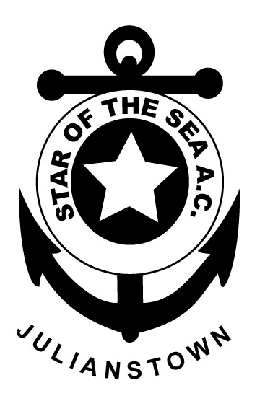

STAR

OF THE
SEA

ATHLETIC CLUB
(EAST MEATH)
JULIANSTOWN
CO. MEATH

Joint Secretaries:
Mary Boland
Mob: 086 8187519
&
Louise Maloney
Mob: 087 6624534

MEMBERSHIP FORM 2019

(Membership valid until 31st December 2019)

Surname:

Name(s): Date of Birth:

Address:

Contacts:
Home
Mobile
Email

Previous Athletic club(s) if any:

Medical Conditions or Prescribed Medication e.g. asthma etc.:
Signature: (In the case of a person under 18 years it should be signed by Parent/Guardian. Membership forms will not be processed unless they are signed):
I/We have also read notes on page 2 of membership form)

Annual Fee: Juvenile (under 19): € 90
(Juveniles must be at least 7 years of age to join the club)
Senior: € 40
Family: (2 Adults & 1 Juvenile Under 19: €135
1 Adult & 2 Juveniles Under 19: €195
2 Adults & 2 Juveniles Under 19: €205
2 Adults & 3 Juveniles Under 19: €280

See Notes on payment Schedule on Next page

STAR OF THE SEA ATHLETIC CLUB MEMBERSHIP NOTES 2019
(Only return page 1 of document to the club registrar or a club coach)

Payment Schedule: As a result of a motion passed at our AGM there will be no hall fees collected each night at juvenile training instead those fees are now built into our annual membership fees. The juvenile training fee for the year will be €60 half of which falls due at the last week of January with the remaining €30 paid at the beginning of Sept. The new juvenile training fee represents a saving of €30 over the full year of 36 training sessions compared to the old training fee structure as well as saving the club the workload of collecting and banking coin from each of our training sessions.

Membership Type | Fee Due In Jan € | Fee Due In Sept € | Total €
Adult | 40 | 0 | 40
Juvenile | 60 | 30 | 90
2 Adults + 1 Juvenile | 105 | 30 | 135
1 Adult + 2 Juveniles | 135 | 60 | 195
2 Adults + 2 Juveniles | 145 | 60 | 205
2 Adults + 3 Juveniles | 190 | 90 | 280

For all club news please keep checking the official club website:
www.staroftheseaac.com

Juvenile Membership:
•All parents of Juvenile Members are reminded that they are requested to stay onsite during club training. For Parents & Guardians peace of mind, Star of the Sea A.C. follows Athletics Ireland Child Welfare & Code of Ethics Practice. A link to that document is available on Star of the Sea A.C.’s official website.

• Keep an eye on the website or Facebook for weekly juvenile fixtures.

- Please make sure your child is physical fit and healthy to partake in strenuous activity. If in doubt, a doctor’s medical examination is advised.

- I understand that photographs or film may be taken at or during sport related events and maybe used in the reporting or promotion of the sport. If you do not wish your child to be photographed or filmed please advise the club Children’s Officer.

- By becoming a member of Star of the Sea AC juveniles will be expected to compete for the club on at least 3 occasions during the year.

Adult Membership:
• By becoming a member of Star of the Sea A.C., you admit that you are in good health and fit for exercise. Star of the Sea advises all adults to undergo a full medical examination prior to joining the club, training and participating in Athletics Ireland events. If you have any medical issues, please state on membership form and if deemed necessary attach a medical certificate to prove you’re fit for exercise.

• We also have recreational Fit4Life Membership available for adults, to improve health & fitness.

• FYI: as a Registered Member of Star of the Sea A.C., you are agreeing to comply with the Irish Sports Council Anti-Doping Policy – Everybody over 18 can be randomly drug tested – no matter how big/small the event. Please check their website if in doubt of any ingredients in medicines/ supplements etc.

