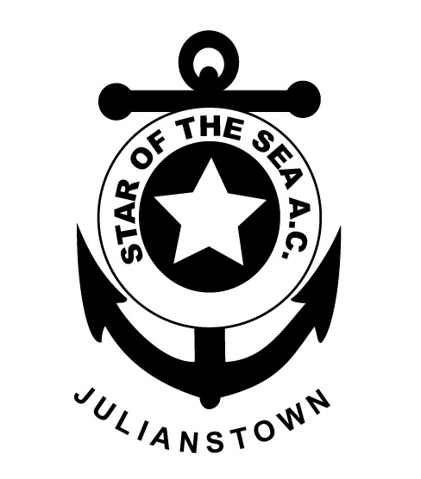

|  |
| --- |
| STAR |
| OF THE |
| SEA |
| ATHLETIC CLUB |
| (EAST MEATH) |
| JULIANSTOWN  CO. MEATH |

Secretary:

Michelle McKiernan  
 3 Gormanston Rd.,  
  Stamullen,  
  Co. Meath  
  
 Mob: 086 1722749

*MEMBERSHIP FORM 2017*

(Membership valid until 31st December 2017)

|  |
| --- |
| **Surname:** |

**Name(s): Date of Birth:**

|  |  |
| --- | --- |
|  |  |
|  |  |
|  |  |
|  |  |
|  |  |

**Address:**

|  |
| --- |
|  |
|  |
|  |

**Contacts:**

|  |  |
| --- | --- |
| **Home** |  |
| **Mobile** |  |
| **Email** |  |

**Previous Athletic club(s) if any:**

|  |
| --- |
|  |
|  |

**Medical Conditions or Prescribed Medication e.g. asthma etc.:**

|  |
| --- |
|  |
|  |
|  |

**Signature: (In the case of a person under 18 years it should be signed by Parent/Guardian. Membership forms will not be processed unless they are signed):**

**I/We have also read notes on page 2 of membership form)**

|  |
| --- |
|  |

Annual Fee: Juvenile (under 19): € 30

(Juveniles must be at least 7 years of age to join the club)

Senior: € 40

Family: (1 Adult & 2 Juveniles Under 19: € 75

2 Adults & 2 Juveniles Under 19: €85

2 Adults & 3 Juveniles Under 19: €100

**STAR OF THE SEA ATHLETIC CLUB MEMBERSHIP NOTES 2017**

(Only return page 1 of document to the club registrar or a club coach)

For all club news please keep checking the official club website:

[www.staroftheseaac.com](http://www.staroftheseaac.com)

**Juvenile Membership**:

•All parents of Juvenile Members are reminded that they are requested to stay onsite during club training. For Parents & Guardians peace of mind, Star of the Sea A.C. follows Athletics Ireland Child Welfare & Code of Ethics Practice. A link to that document is available on Star of the Sea A.C.’s official website.

• Keep an eye on the website or Facebook for weekly juvenile fixtures.

* Please make sure your child is physical fit and healthy to partake in strenuous activity. If in doubt, a doctor’s medical examination is advised.
* I understand that photographs or film may be taken at or during sport related events and maybe used in the reporting or promotion of the sport. If you do not wish your child to be photographed or filmed please advise the club Children’s Officer.
* By becoming a member of Star of the Sea AC juveniles will be expected to compete for the club on at least 3 occasions during the year.

**Adult Membership:**

• By becoming a member of Star of the Sea A.C., you admit that you are in good health and fit for exercise. Star of the Sea advises all adults to undergo a full medical examination prior to joining the club, training and participating in Athletics Ireland events. If you have any medical issues, please state on membership form and if deemed necessary attach a medical certificate to prove you’re fit for exercise.

• We also have recreational Fit4Life Membership available for adults, to improve health & fitness.

• FYI: as a Registered Member of Star of the Sea A.C., you are agreeing to comply with the Irish Sports Council Anti-Doping Policy – Everybody over 18 can be randomly drug tested – no matter how big/small the event. Please check their website if in doubt of any ingredients in medicines/ supplements etc.